Problem Statement:

* There are two competing teams which have to collect balls (ping pong) placed at a height and then drop into a pathway which is connected to a balance mechanism.
* Each team has to prepare two bots, one bot (travelling bot) should cross the hurdle (anyone of the two) and drop them in the pathway (as shown).

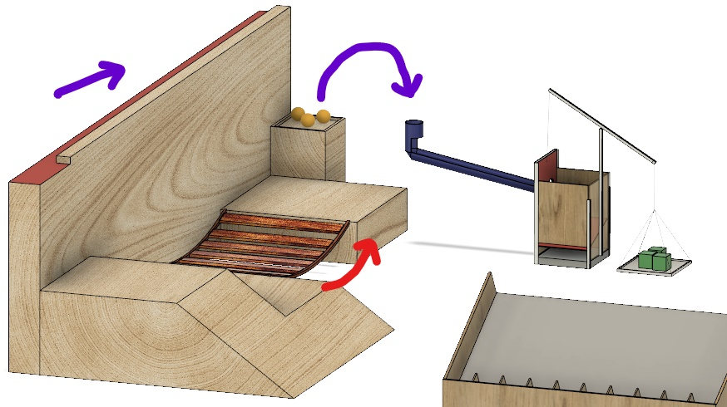

* This pathway of the ball ends on a wooden gate. For the balls to move further, the other bot should place cube shaped weights on one side of balance mechanism. (detailed description below).
* While one bot travels past the hurdle, the other bot have to place the cube shaped weights on the balance which opens the gateway into a box.
* After desired no. of balls are dropped into the box, the weights on the balance have to be removed by the other bot to collect the balls.
* Then the bot should pick the ball from ground and place it on a scoring wedge so that the ball randomly land on a number (low weightage) (whose value will be gained as points by the team)

Brief overview of tasks:

TRAVELLING BOT

* When the bot enters the arena, it has two paths to reach the balls:

1. Via a ropeway bridge.

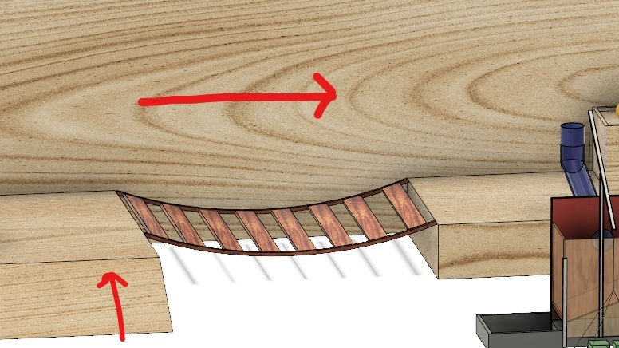

1. Via a wall-mounted grove

GREEN ZONE

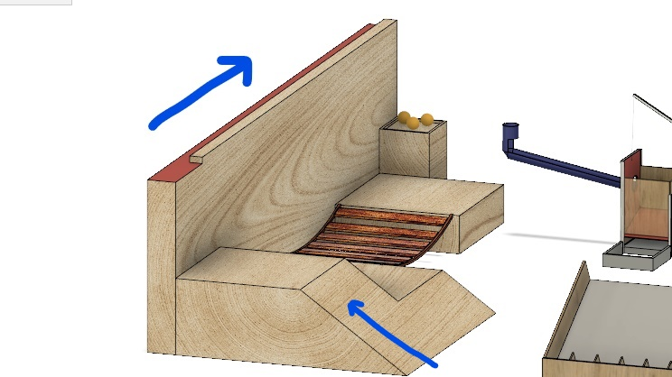

* The travelling bot is supposed to have a picking mechanism (for balls) and an appropriate mechanism to cross a hurdle (chosen one).

PICKING BOT

* This bot's function is to pick and place the cube shaped weights on the balance.
* It is also used to pick balls and place it on the scoring wedge to gain extra points.

BALANCE MECHANISM

* Initially, when the weights are not placed the inlet gate for the balls is closed.

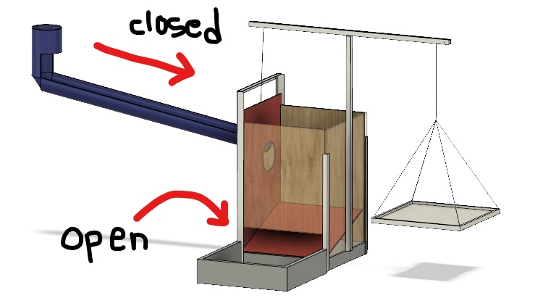

* As the picking bot places the cube weights on the balance, a wooden gate moves upward giving way for the ball.

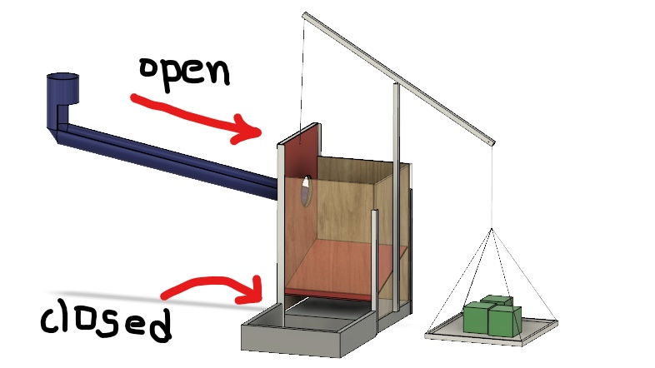

* After desired no. of balls are dropped, the weights have to be removed to collect the balls.



* Then finally it places the ball on a scoring wedge (as shown below) for extra points.

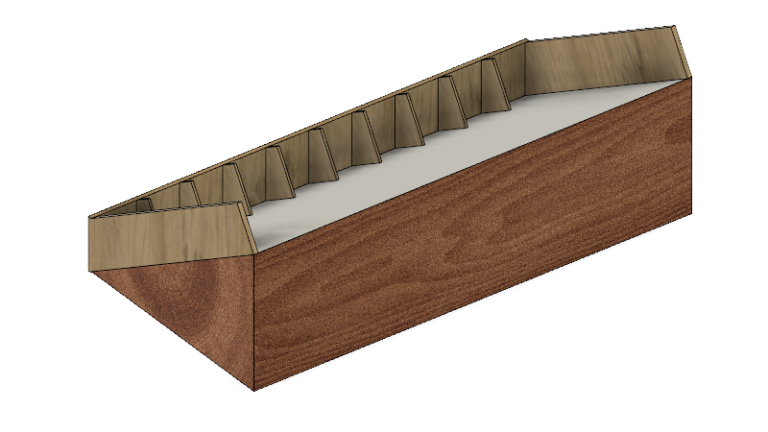

MEASUREMENTS:

* **CUBE** - **50mm side**
* **BALL - 40mm Diameter**
* **Dimensions of the robot (maximum) - 40cm (length)** X **40cm (breadth)** X **25cm (heigth) (EXCLUDING ARM LENGTH)**
* **Green zone is of 70cm length (from the last)**

RULES AND REGULATIONS:

* **Maximum weight of the robots allowed is 5-6kg.**
* **(to pick up the balls) Arm should be used only when the robot lies completely in the green zone (or) in the case of ropeway, arm should be used only after crossing the bridge completely.**
* **Arm of the traveling robot can extend to any length after entering the green zone.**
* **Travelling bot should drop the balls into the pipe way only.**
* …………. WILL BE UPDATED……….

CONDITIONS:

SCORE SHEET :